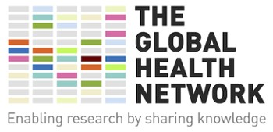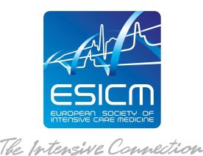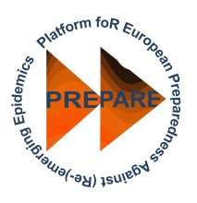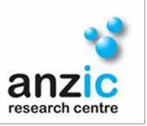FREE Education and Training
2016

SPRINT-SARI includes an opportunity for researchers & clinicians to improve their confidence and skills in planning, designing and conducting research.

CERTIFICATES AWARED UPON TRAINING COMPLETION
Good Clinical Practice (GCP) Training
A key standard for anyone involved in the conduct of clinical research is Good Clinical Practice (GCP) training. GCP is the ethical and practical standard to which all clinical research is conducted. FIRECREST makes real-time training interactive, user-friendly and fast. Complete the training at your own pace. To register your interest please email mnhs -sprint.sari@monash. edu

The Global Health Network Training Centre Brings together a wealth of training materials and resources for all your research training and continued professional development needs. This platform is completely free, accessible to all and aims to provide
research staff of all roles, all regions and all disease areas with the ‘how-to’ training materials required to safely conduct high quality research. For more information, visit TGHN website

2016

[INSERT NETWORK NAME]

[INSERT TEXT HERE]

If you provide local training opportunities. Please list them on this page for publications

