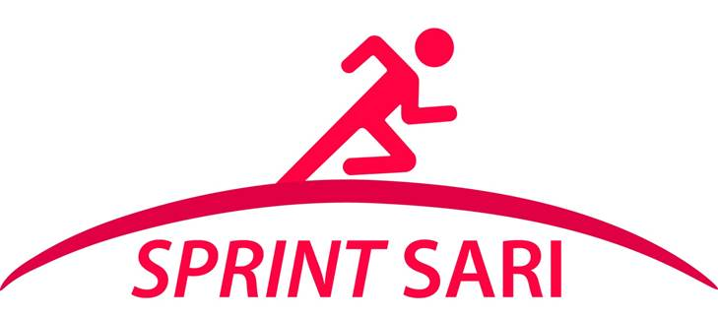
Patient name:
PARTICIPANT IDENTIFICATION #: [___][___][___]- [___][___][___][___]

[***Hospital letter head***]

Local lead investigator: [***local_lead***]

Short Period Incidence Study of Severe Acute Respiratory Infection (SPRINT-SARI)
INFORMATION SHEET FOR YOUNG PEOPLE AGE 12 TO 16 YEARS OLD

We are undertaking a research study involving people with severe new chest infections (SARI) with MERS-CoV or Influenza A/H7N9 or A/H5N1 or other infection. We have come you to ask if you would be willing to help us because you have a chest infection.

Before deciding if you want to be involved, it is important for you to understand why this research is being done and what it would involve for you. One of our team will go through the information with you. Please ask us if there is anything that is not clear, or if you would like more information

What is the study about?
- Infectious diseases affect millions of people around the world every year.
- New infections appear. Most cases are mild, but some people become very unwell.
- There is a lot that we do not understand about these new infections.
- By understanding why young people like you are unwell we can try to find better ways to manage and treat people in the future.

Do I have to take part?
- It is up to you and your parents/guardians/carer to decide if you should be involved in helping us.
- If you don’t want to be involved, then you don’t have to.
- Either way, your decision will not affect your care and treatments in any way.
- The choice is yours.

What will happen if I take part in this study?
We will collect information from your clinical records when you are in hospital, including medication taken and laboratory results.
What will happen to my information?
All information about you will be kept private and confidential. Only the people responsible for your care at the hospital and for this study will know that you were involved in this study. The results of the study will be shared as quickly as possible with health authorities, and doctors to help them treat patients with severe acute respiratory infection.

The confidential clinical data collected will also contribute to an international a multi-centre, short period incidence observational study of patients with SARI. The study period will comprise a 5 to 7-days.
We will review your medical records and keep limited information about you on a secure file. All information will be labelled only with a number so that they cannot be directly linked to you personally. .

Are there any benefits to taking part in this study?
There are no benefits for you personally. By helping us find out more about why you are ill, we will be able to help look after young people better in the future.

What are the risks of being in the study?
If only clinical data is collected there is a minimum risk, all information will be used anonymously (no one will know your name).

