**SPRINT-SARI study is supported by:**

***The study period in this hospital is:***

**A history of fever**

**or measured fever ≥ 380C**

**Throughout the study period we will collect anonymised data on patients who meet the inclusion criteria.**

**Dyspnoea (difficulty in breathing or shortness of breath) and/or  
Tachypnoea (abnormal rapid breathing).**

**With one or more of the following:**

**Onset within the past 14 days,**

**Cough**

**A suspected or proven acute respiratory infection requiring new inpatient admission to intensive care, in a person of any age, with:**

**If you agree:**

**Your anonymised data will be shared with the SPRINT-SARI study research team.**

**By participating in the study this hospital is establishing an epidemic/pandemic research response capability.**

for more information on this study visit [www.isaric.org](http://www.isaric.org)

***Leading the study at your hospital is:***

*Inclusion Criteria*

***For more information contact:***

**SPRINT-SARI is a global observational study on Severe Acute Respiratory Infection (SARI).**

***Clinical Characterisation Protocol for Severe Emerging Infection (CCP)***

***Activation week - Anonymised data contribution to SPRINT*-SARI**

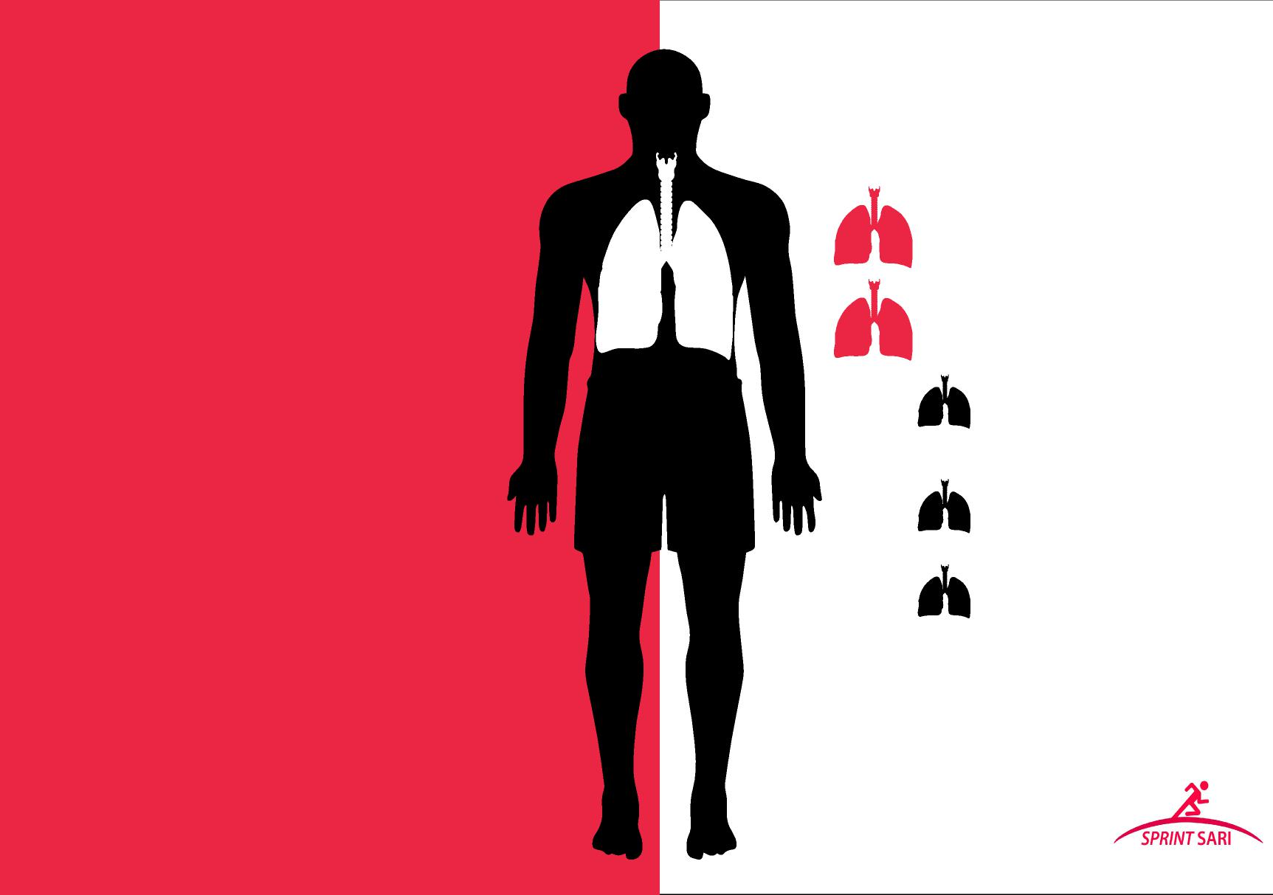

**ANZIC RC, ISARIC, InFACT, PREPARE and ESICM**