DAY 1 (D1) RECRUITMENT SAMPLE PACK CONTENTS FOR CHILD <40kg (PRE-LABELLED PACK)
Item | Trade example (based on UK availability) | Reference picture | Number required in adult D1 pack | Comments
K2 EDTA (spray-coated) blood tube 3ml (plastic) | BD Vacutainer 367838 |  | 3
Plain clotted blood tube 4ml (plastic) | BD Vacutainer 368975 |  | 1 | 3ml BD tube not available in Europe; 4ml tube to be filled with 3ml blood
Tempus blood tube (glass) | Tempus Blood RNA Tube 4342792 (Vacuette) |  | 1 | Caution – fragile glass
Sterile universal container for urine, 30ml | Sterilin 128A/FS |  | 1
Stool container, 30ml | Sterilin 128SA | 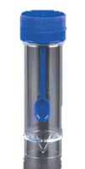 | 1
Sterile suction trap 30ml with sealable screw-cap | Pennine Healthcare MST-3000 or MST 3070 | 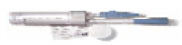 | 1 | Connector colour may differ
Sterile 10CH (3.3mm) suction catheter, 50 cm length | Kendall Argyle 1180-851105 Touch-Trol (Tyco Healthcare Ltd) |  | 1
Small plastic bag containing ETA and NPA sample labels | NA | 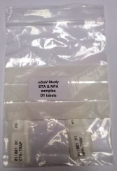 | 1 | Only needed if using packs containing pre-labelled consumables
Small plastic bag containing sputum sample, flocked swab & infected site swab labels | NA | 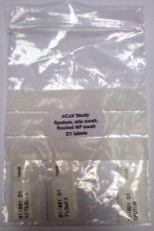 | 1 | Only needed if using packs containing pre-labelled consumables for a specific subject
SERIAL AND WEEKLY SAMPLE PACK CONTENTS FOR ADULTS
Item | Trade example (based on UK availability) | Reference picture | Number required in adult D1 pack | Comments
K2 EDTA (spray-coated) blood tube 3ml (plastic) | BD Vacutainer 367838 |  | 1
Plain clotted blood tube 4ml (plastic) | BD Vacutainer 368975 |  | 1 | 3ml BD tube not available in Europe; 4ml tube to be filled with 3ml blood
Tempus blood tube (glass) | Tempus Blood RNA Tube 4342792 (Vacuette) |  | 1 | Caution: fragile
Sterile universal container for urine, 30ml | Sterilin 128A/FS |  | 1
Stool container, 30ml | Sterilin 128SA |  | 1
Sterile suction trap 30ml with sealable screw-cap | Pennine Healthcare MST-3000 or MST 3070 |  | 1 | Connector colour may differ
Sterile 10CH (3.3mm) suction catheter, 50 cm length | Kendall Argyle 1180-851105 Touch-Trol (Tyco Healthcare Ltd) |  | 1
Small plastic bag containing ETA and NPA sample labels | NA |  | 1 | Only needed if using packs containing pre-labelled consumables
Small plastic bag containing sputum sample, flocked swab & infected site swab labels | NA |  | 1 | Only needed if using packs containing pre-labelled consumables for a specific subject

EXAMPLE D1 CHILD <40kg SAMPLE PACK WITH PRE-LABELLED CONSUMABLES FOR SUBJECT 01/001
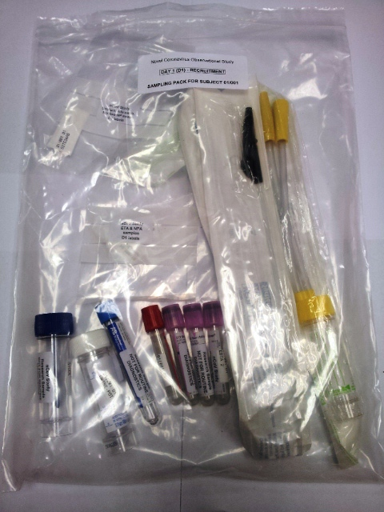
- The sample pack shown above contains pre-labelled D1 consumables for subject 01/001, so the main bag is also labelled specifically for D1 sampling from subject 01/001
- Specimen containers should be pre-labelled “ISARIC RESEARCH SAMPLES – NOT FOR ROUTINE DIAGNOSTICS”
- It is advised that in addition to time-point-specific sample packs, a pack containing spare consumables is also available at all times (in case consumables break etc.)
- Flocked swab in UTM e.g. Copan 305C is not shown; these swabs may either be available locally or can be carried in the ‘spare consumables’ pack
- Infected site swabs include flocked swab in UTM (see above), a general purpose bacterial culture swab e.g. Sterilin Aimes transport swab 18108CST, or a plain rayon general purpose swab for molecular analysis e.g. Sterilin F155CA; these may either be available locally or can be carried in the ‘spare consumables’ pack
- Additional “ISARIC RESEARCH SAMPLES” labels for the ETA or NPA specimen can be included (loose) in the pack, or carried in the ‘spare consumables’ pack

